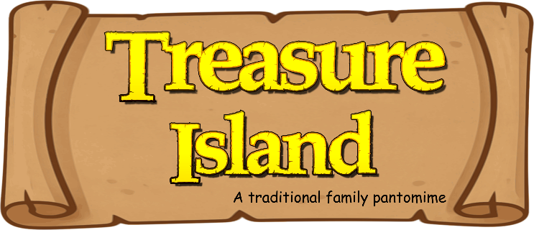
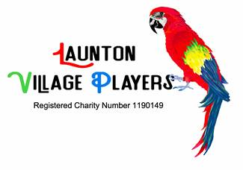

Advertising in the Launton Pantomime Programme 2026

Our 2025 panto raised a wonderful £12,500 for The Hummingbird Centre. We could only achieve this with the help of local businesses like yours advertising in the programme. I’m approaching you now to ask if you will support us this year as Launton Village Players stage another original Pantomime:
“Treasure Island”

The Launton Village Players Pantomime has been a tremendous success over the years and many of our performances sell out. As well as giving a lot of pleasure to our audiences of both adults and children, our players have raised over £165,000 for charity. We’ve done this with the support of many people, including our advertisers.

This year we are raising money for Dementia Oxfordshire and Dementia Active, two charities who provide activities, support and opportunities for those diagnosed with dementia, and their families and carers in the local area.

Once again we are including more accessible seating for every show, as well as a “relaxed performance”, so all of our audience can be included. Our programmes will be available for sale for only £2 to our family audiences on all 7 performances reaching a potential of over 1400 people!

The cost of advertising hasn’t changed for many years, and this year we’re again offering the choice of black and white or colour ads. The prices are:

Size Height x Width | B&W | Colour
Full A5 Page (210mm x 148mm) | £100 | £150
Half A5 Page (105mm x 148mm) | £60 | £80
Quarter A5 Page (105mm x 74mm) | £35 | £45
Please indicate on the attached order form the size of advert you require, and give any specific details. Our programme editor can create an advert for you using Panto themes, can scan and use something you have created yourselves, or can accept your artwork emailed as a jpeg file. Please send any logos or artwork to advertising@launtonvillageplayers.org.uk. Maybe you could add a voucher code to your ad, to keep track of feedback.

When you agree to advertise in the programme for “Treasure Island” we’ll invoice/receipt you for payment. Please let us have your instructions and the payment as soon as possible to help us finalise the layout of the programme. After the show, we’ll send a copy of the programme page containing your advert.


Thank you again for your support.

February 18th, 19th, 20th and 21st 2026
Cooper School Performance Hall
www.launtonvillageplayers.org.uk
advertising@launtonvillageplayers.org.uk

Advertising in the Launton Pantomime Programme 2026

I wish to order an advertisment in the programme for the 2026 Launton Village Pantomime

Company Details

Trading name |  | Business Name:
Address
 |  |  | Post Code:
Order placed by |  | Contact Name:
Business Type: |  | Email:
Accounts Details

Contact Name:
Tel No: |  | Email:
Advert Details (please tick)
Height x Width B&W Colour
Full A5 page 210 x 148mm £100 £150
½ A5 page 105 x 148mm £60 £80
¼ A5 page 105 x 74mm £35 £45

Source for ad

- Same as last time Create an ad for me
Use the attached advert/business card/logo I will email you a jpg to:
I want to see a proof

Payment Methods

- Bank Transfer
Cheque
Cash

Cheque/Transfer to: Launton Village Players - Sort Code: 08-92-99 Account No: 65975730
Please ensure payment is made by 5th January 2026 to secure your place.

Other notes

February 19th, 20th, 21st and 22nd 2025
Cooper School Performance Hall
www.launtonvillageplayers.org.uk
advertising@launtonvillageplayers.org.uk

